# Learning and working with Python

Learning python wasn’t a big issue for me, though I have rarely worked with a scripting language, it was easy enough to pick up. When first starting out it was intimidating, it’s a lot of change all of a sudden with how lose it is. This is relevant with defining variables for example. Within one of the first lessons I named a variable “list” overwriting the method within Python, this confused me when I had to use the method in the tutorial. Regardless of the complications, I liked working with the language and overcoming the assignment. This came down to me trying to get everything perfect in the Python Basics assignment and getting positive feedback from Gerard.



Working with the libraries was a completely new experience. It was hard to wrap my head around and, like mentioned plenty during our lessons, the documentation was hard to understand. Now I understand the basics of Pandas and NumPy everything is making more sense and I can enjoy programming with SVM without many issues. Due to these experiences, I have learned how to read and apply professional documentation.

# Documentation and delivery

Documentation has always been an issue for me. Writing sentences that make sense and having a proper structure are difficult for me. The business side of ADS was challenging for this reason, if you don’t word it out properly, it is not good enough. This means I had to be careful with what I typed and redo a lot of my segments. This was noticed the most during proftaak, people expect quality and I want to deliver on that. Having the documentation be in English made my life a bit easier. Even though I’m pure Dutch, my English can often times be better than my Dutch.

Even with the few deliveries I’ve missed, I have never been satisfied with my delivery rate. This is due to a lot of time based issues coming from the main stream and from my personal life. This is something to look out for more in the future, be more careful with planning deliveries and also deliver work even if it is unfinished.

# Project Group

Coming in to the project group, I was negative about working together with the people in my group with a few exceptions. People were loud and not really my kind of people, yet it had to happen. I have been lucky that Katherine had taken the lead upon herself and tried to push everyone to do something. I tried to respond as positive as possible and do my work as asked. Through the project itself I noticed that many people started to do less when not asked and Katherine getting more annoyed with the group as a whole. I tried to come a bit out of my shyness and ask people to do the tasks handed towards them. This turned out to be a good move and later within the cycle people started to work on the business case. Even though our teamwork has not been well, we delivered the business case and the overall feedback was positive. I have done my best to be a good addition to the team and delivered my work when asked.

# Personal development within ADS

I’ve never been an action taker and like to get tasks assigned that I need to do. This does not mean I don’t take action when needed. Like mentioned before, I have had to change my attitude towards the group to get work done. This had been an exciting experience for me and I’m glad to have done this. I do feel more confident in taking the lead in projects and will try to do it more in the future. Due to me and Katherine having the main course and ADS together, I started talking to her more and work together for assignments. This means a lot of social contact, planning and explaining which I am not used to. I’ve always been a shy person due to personal issues and this semester’s experience has got me more out of hiding. I feel more free to express myself and share my ideas that I would normally keep for myself.

Like mentioned before, I have not found a big liking in my project group as they are not my type, holding me back from developing socially. I do see this as another good experience, working together with people who you might not like is also a skill that many need to learn when going into a job. I’m glad I got this down and I have learned a lot from trying to co-operate with these kind of people.

My personal life has been a bit shaky as of this current time, I’ve had to enter therapy and change my mindset about everything. This was often times hard to combine with ADS. I’m not a fan of being between unknown people and find this terrifying at most times. On bad days, it was a challenge to show up and follow what was going on without my mind drifting into different places. I managed to get through this fairly well, learning about the subjects and consistently showing up (with a few exceptions in regards to appointments). I have not informed Gerard or Bas of this because I felt that it was unneeded, I am trying to get back to normal behavior and trying to get through this without help was a great exercise. I am happy it has gotten to this and excited to see the future.

# The challenges

For right now, I have only worked on challenge 1 and read through 2 and 3. This is because of the big workload that has happened during the time of end October. I was planning on starting the challenges during mid-October since I would have all the knowledge and could start working out everything in quick succession. Yet due to the big workload from the main course and my therapy, I was unable to start at the time that I would have liked. Leading me to getting into time issues. The challenges themselves look like a good test of what you have learned in the core. They test your knowledge of programming with python and seeing the business side as well. I’ve had a good time working on these challenges and really felt like I was let free on this dataset. The features are manageable and meaningful (something I am missing from the proftaak dataset) and there have been examples on how to work with this kind of data. I’ve gotten together with Katherine to work on challenge 1 since we can fill each-others qualities well. I’ve spend most of my time within Challenge 1 to work on the custom KNN method. We later found out that this was optional but I had a fun time programming it and saw it as a challenge.

I have tried to make it as flexible as possible with the dataset and k input, automatically scaling to the features provided. Unfortunately I ran into a wall when getting KeyErrors when trying out the entire dataset. These errors are very undescriptive and looking them up results in nothing being found. To this day, I’ve been unable to find the exact cause of these errors making my KNN method not run at full potential.

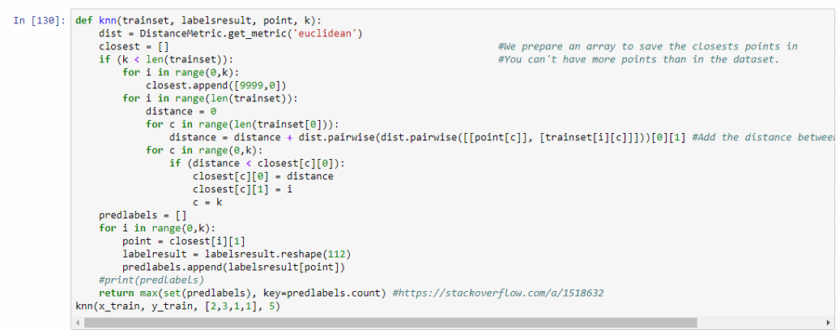

The knn method I had written myself using the Euclidean metric.

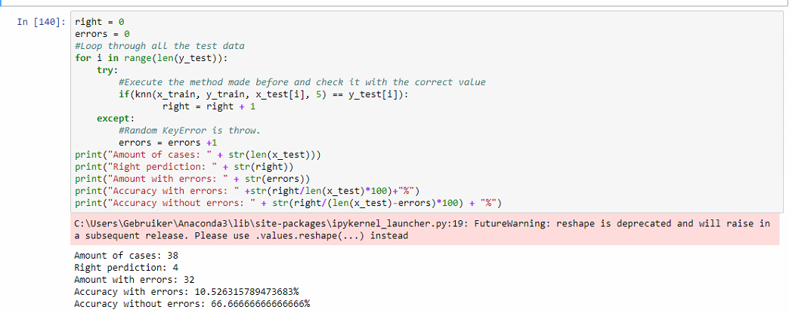

As you can see, I’m encountering a lot of errors when trying to use it on the entire test set. This means my algorithm has a very low accuracy. When we retract the errors we can see that the accuracy is not bad. Anything over 50% I am very happy with and I do feel satisfaction in writing this piece of code.

# Conclusion

When starting out ADS seemed really rough and I had a ton of issues with it, through excellent help from the teachers and starting to understand the basics, I have managed to get into it and enjoy the course. I’ve learned a lot about teamwork and managed to explore myself more as a person. I’ve learned to stand up for myself and try to talk more to people even if there are no shared interests.